Taranaki Secondary Schools Rogaine Championships

Taranaki appears to have a jump on the rest of the country when it comes to school’s rogaining. This year’s Secondary Schools Championships were keenly contested by 150 school students ranging in age from 11 to 18. That’s right 150. The event was run over 3 hours (6pm till 9pm) in Lake Mangamahoe on a Wednesday evening. The timing meant that competitors were out for an hour of darkness which added to the fun.
.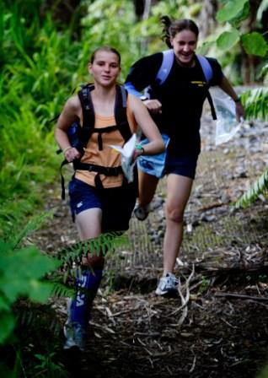
Dayna Marshall (left) and Nicole Mace, from Inglewood High School race to their first control in the Taranaki Secondary School Rogaine Championships
Photo: Taranaki Daily News
The championship event followed on from a 12 week (3 hour summer) series run on a New Plymouth map. Separate foot and bicycle grades were offered. These events attracted up to 85 competitors, many of them students.

After years of unsuccessful marketing of orienteering to the schools, the enthusiasm for this incarnation of the sport has caught the club by surprise.

There is no doubt that the “Teams” aspect of the sport is highly attractive and probably holding the event reduces competition with other activities such as homework.

Regardless, there is no doubt that enjoyment levels were high for both the “hard-outs” and the “picnic-ers”. Support from the secondary school sports coordinator helped significantly in selling the event.

We look forward to the first National Secondary School Rogaine Championships which can’t be far away now.

