O-Max – 2006

Afterwork Park Orienteering Series
Hutt Valley and Wellington Orienteering Clubs present:

Cash Prizes for the Series Result:
Top Open Woman,
Top Open Man!
Top Veteran,
Winning Students too!
Small prizes nightly.

What: Viewer friendly orienteering in parks close to home. Fast action packed racing - hesitation will cost you! Just like the Ericsson Park World Tour for elites. And simultaneously white and yellow courses with help for newcomers – bring your friends.

O-MAX is a six race series 2-3 km each in Wellington and Hutt Valley parks. Sprint-distance orienteering, with surprise features continually being invented. Up to six starts at once with course splits. Pre-marked colour maps. Loops and ‘Wild Card’ controls. PA commentary. Instant results.



O-Max – 2006
Afterwork Park Orienteering Series
Hutt Valley and Wellington Orienteering Clubs present:

When:
O-MAX 2006 runs after work during November and December. Starts from 6:30pm (1-5km White and Yellow-level courses for beginners also available 6-7pm)

Season ticket 6 for the price of 5, enter on the form overleaf. Or enter on the night by 6pm, while maps last. White and yellow courses enter on the night.

Enquiries Michael Wood Ph 5662645 michael.wood@mapsport.co.nz

PRIZEGIVING at the final event at Massey Campus

Where:

Tuesday 31 Oct: Silverstream Retreat (follow “Rly Museum” from Sstream Br)
Wednesday 8 Nov: Macalister Park, Wgtn (signposted from Adelaide Rd)
Thursday 16 Nov: Avalon Park, Lower Hutt (signposted from Fairway Drive)
Tuesday 21 Nov: Botanical Gardens, Wgtn, (signposted from Glenmore St)
Wednesday 29 Nov: California Park, Upper Hutt (signposted Totara Park Rd)
Thursday 7 Dec: Massey Wgtn Campus (signposted from Taranaki St)
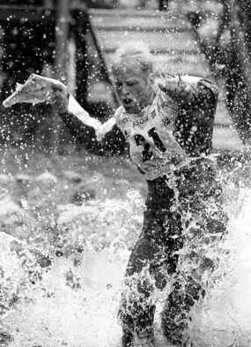
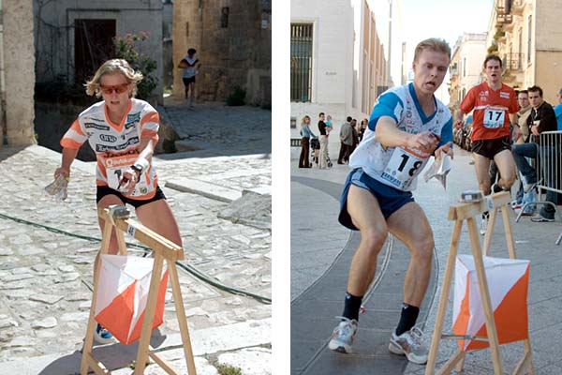
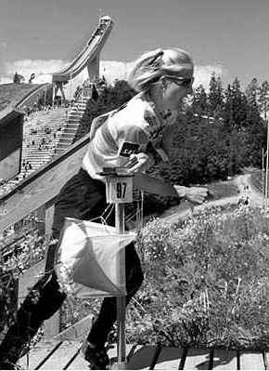

O-Max-2006: the Fine Print.
$2.50 of each senior entry fee will go into three pools, one for men, one for women, one for veterans 40+. $1.50 of each school student entry fee will go into two pools, one for boys and one for girls. They will provide cash prizes based on the results of the series as a whole; The winners of the five classes collect the respective prize pools
Your points are your placing in class (DNS or DNF is last plus 1.) Count your best 4 scores, lowest wins. Course planner may count best other result in series for his/her event.
Just in case clause: If anything prevents a fair competition, the WOA OY Complaint procedure may be used. The organisers may award prizes based on fewer than 6 competitions.

- - - - - - - - - - - - - - - - - - - - - - - - - - - - - - - - - - - -
Yes! I want to enter O-MAX-2006!

My Class: Mens Open/Womens Open/Veterans /School Boys/School Girls (circle)

Yes! I want to enter on days:
31 Oct /8 Nov /16 Nov /21 Nov /29 Nov/7 Dec (circle)

Name

Address

E-mail

Phone Club or School

Entry fee $6 per event open/veteran $3 school student.

Season Ticket: Enter all six events for five entry fees, that is $30 open/veteran or $15 school student. Must be in the PO Box by 10am Friday 27 October.

Entries on the night same price while maps last, but may be black/white instead of colour. Make sure of your colour map by entering prior to the series. Cheques to “Orienteering Hutt Valley”; or transfer to 010514 0135615-00. Include in particulars/code/ref runner’s name(s) and “OMAX06”

Post this form to “O-Max”, Box 30398, Lower Hutt to ARRIVE on or by 27 Oct

